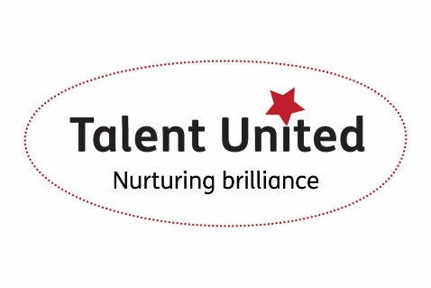

**Talent United**

**Partnership Agreement**

**Employer Details**

**Company:**

**Main Contact:**

**Position:**

**Address:**

**Postcode:**

**Telephone:**

**Email:**

**Website:**

**Social Media:**

**Engagement Opportunities**

|  |  |  |  |
| --- | --- | --- | --- |
|  | Apprenticeships |  | Workshops/Seminars |
|  | Work Placements |  | Mentoring/E-Mentoring |
|  | Volunteer Opportunities |  | College Staff Professional Development |
|  | Work Experience |  | Attendance at events |
|  | Workplace Visits/Tours |  | Award Nomination/Judging/Sponsorship |
|  | Curriculum Input |  | Student Sponsorship |
|  | Sponsored/Live Assignments |  | Competitions for students |
|  | Guest Speakers |  | Other: |

I am happy to support Barnsley College and become a partner of the Talent United initiative. I am willing to commit to bridging the gap between education and employment by creating opportunities within my business for young people as identified above.

**Print Name:**

**Signature:**

**Position:**  **Date**: