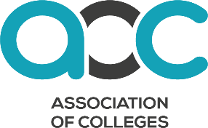

Creative Arts in FE 2024 Consent Form

Please read and complete the below form, ticking or indicating which levels of consent you give for the use of your work.
Digital or physical signatures are accepted.

First name and surname: | College:
I consent for my work to be shared with AoC, CLA and UAL Awarding Body and for it to be included in all future publications (online or in print), social media and website content anonymously.

I am aware of the potential need for my work to be edited/changed for publishing and give my consent for this.

I consent for my work to be shared with AoC, CLA and UAL Awarding Body and for it to be included in all future publications (online or in print), social media and website content with my first name, surname and the college I am from.

I am aware of the potential need for my work to be edited/changed for publishing and give my consent for this.

I do not consent for my work to be shared or published
I acknowledge that copying someone else’s work, or part of it, is plagiarism. I confirm that this submission was created by me and contains no plagiarism.

Signature: | Date:

Please return these consent forms alongside your digital submission by the submission deadline.
If you have any questions further information about the project can be found on the AoC website or your college can email us directly with the contact information we have supplied to them.
The privacy notice for this project can be found on here.

