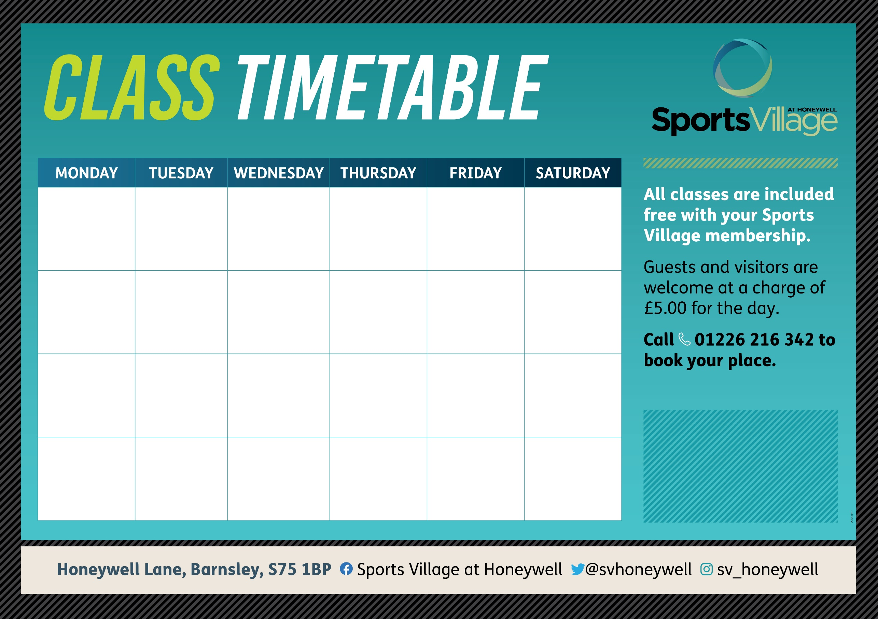
SPIN  6:45AM  30 MINS | FUNCTIONAL FITNESS  6:45AM  30 MINS | LBT BLAST  6:45AM  30 MINS | HIIT  6:45AM  30 MINS | CORE  6:45AM  30 MINS | BOOTCAMP  9:00AM  60 MINS
SPIN  5:30PM  30 MINS | CIRCUIT  5:45PM  45 MINS | PILATES  5:20PM  40 MINS | DANCE FIT  5:30PM  45 MINS | WEIGHT’S CIRCUIT  5:30PM  45 MINS
ENDURANCE CIRCUIT  6:30PM  60 MINS | LBT  6:30PM  40 MINS | BATTLEROPES  6:30PM  60 MINS | KETTLEBELLS  6:20PM  40 MINS

